[Content Generation Tool Documentation](https://inspiring-kitsune-4f7cdc.netlify.app/)

**Introduction**

The Content Generation Tool is a web-based application that utilizes OpenAI's GPT API to generate informative and relevant content based on user input. The tool acts as a personal AI assistant, providing answers and insights on various topics. This documentation will guide you through the functionality, implementation, and usage of the tool.

**Table of Contents**

1. Overview

* Purpose
* User Interaction
* Technology Stack

1. API Integration

* OpenAI GPT API
* API Key Integration

1. Application Functionality

* User Input
* Content Generation
* Error Handling
* Testing and Optimization

1. Deployment

* Hosting the Application
* Serverless Function Setup

1. Conclusion

**1. Overview**

Purpose

The purpose of the Content Generation Tool is to provide users with a personal AI assistant capable of generating informative content based on user input. The tool leverages OpenAI's GPT API to generate responses and aims to assist users by providing helpful and relevant information.

User Interaction

Users interact with the application through a web interface. They input their prompts or questions into a text field and receive responses generated by the AI assistant. The conversation history is displayed in a dedicated container, allowing users to view the entire conversation.

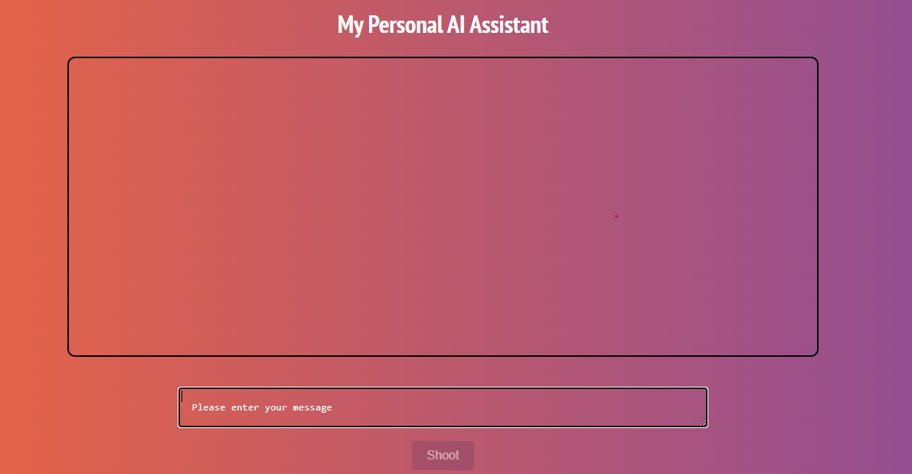

Technology Stack

The Content Generation Tool is built using the following technologies:

* **HTML:** Provides the structure and layout of the web application.
* **CSS:** Styles the user interface elements to enhance the visual appeal.
* **JavaScript:** Implements the logic and functionality of the application.
* **OpenAI GPT API:** Integrates with the AI model for content generation.

**2. API Integration**

OpenAI GPT API

The OpenAI GPT API is a powerful tool that allows developers to access the capabilities of OpenAI's GPT models. It enables the generation of human-like text based on user prompts.

API Key Integration

To integrate the OpenAI GPT API into the Content Generation Tool, an API key is required. The API key authenticates your requests to the API. In this application, the API key is securely stored in a serverless function and fetched when needed.

**3. Application Functionality**

User Input

Users interact with the application by entering prompts or questions into a text field. The user input is then sent to the OpenAI GPT API for content generation.



Content Generation

The Content Generation Tool utilizes the OpenAI GPT API to generate informative and relevant content based on the user's input. The API processes the prompt and returns a response generated by the AI model. The response is then displayed in the conversation container, maintaining the conversational flow.

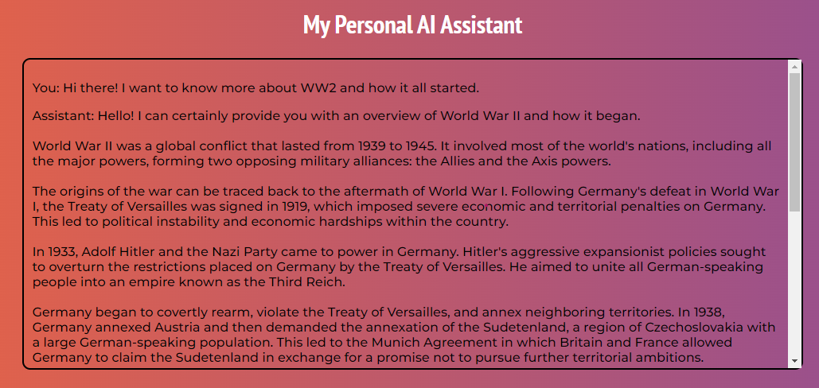

Error Handling

The application implements error handling to manage potential issues that may arise during API integration or content generation. If any errors occur, appropriate error messages are displayed to the user, allowing them to understand and resolve the issue. Edge cases, such as empty or excessively long prompts, have been handled to provide a seamless user experience. The submit button is disabled when the text field is empty, to prevent the user from sending empty prompts. Moreover, once a prompt is being processed, both the submit button and the text fields are disabled to prevent multiple concurrent requests to the API.

Testing and Optimization

The tool has been tested with various types of user inputs to ensure the quality and relevance of the generated content. Various user persons were tried out and it was decided that the *‘helpful assistant’* persona is the best one for content generation. The tool's performance and content generation accuracy have been optimized through iterative testing and adjustments.

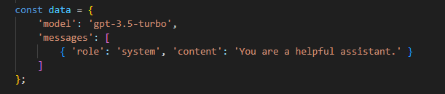

**4. Deployment**

Hosting the Application

The Content Generation Tool can be hosted on any web server that supports HTML, CSS, and JavaScript. For example, you can deploy the application on a hosting platform like Netlify or GitHub Pages. For our purposes, I chose to deploy it on Netlify. The website can be accessed through the following linK: <https://inspiring-kitsune-4f7cdc.netlify.app/>

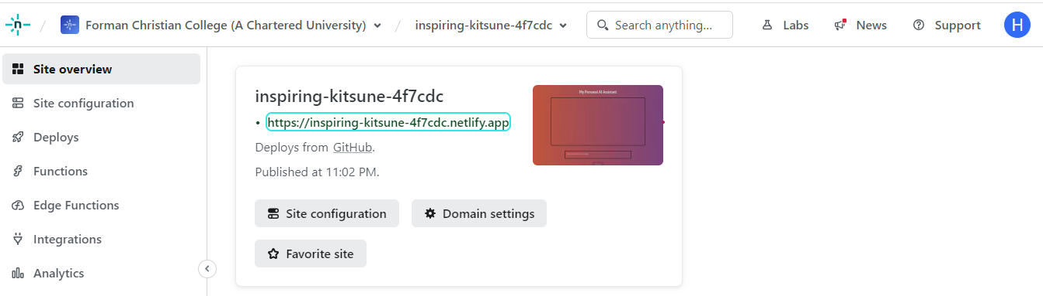

Serverless Function Setup

To ensure the security of the API key, a serverless function is utilized to fetch the API key during runtime. This setup prevents exposing the API key directly in the client-side code, reducing the risk of unauthorized access. The serverless function is implemented using JavaScript and was deployed using Netlify functions.

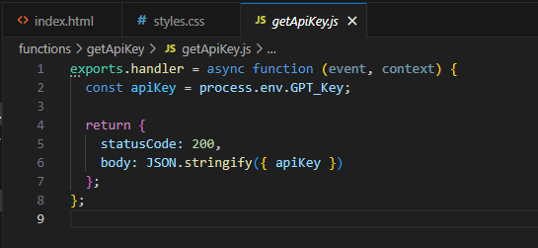

**5. Challenges Encountered**

During the development of the Content Generation Tool, I encountered several challenges. Here are the key challenges and the steps taken to overcome them:

Challenge 1: Bearer Authentication Scheme

One challenge was encountered when integrating the API key into the application using the bearer authentication scheme. Initially, there was limited understanding of this authentication method.

Solution:

To overcome this challenge, thorough research was conducted on the OpenAI documentation to gain a better understanding of the bearer authentication scheme. This helped in successfully integrating the API key into the application, ensuring secure and authorized access to the OpenAI GPT API.

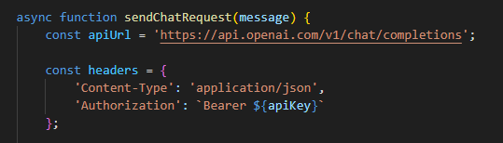

Challenge 2: Hosting and API Key Security

Another challenge was ensuring the security of the API key while hosting the application. Storing the API key directly in the client-side code posed a security risk.

Solution:

To address this challenge, a serverless function was implemented to securely fetch the API key during runtime. This approach prevented exposing the API key in the client-side code, reducing the risk of unauthorized access. The serverless function was set up using JavaScript and deployed using Netlify Functions.

**6. Conclusion**

The Content Generation Tool provides a user-friendly interface for generating informative and relevant content using OpenAI's GPT API. By integrating the AI assistant into your web application, users can obtain helpful answers and insights on various topics. The tool's functionality, error handling, and optimization make it a valuable asset for content generation.

With this documentation, you have a comprehensive guide to understanding and utilizing the Content Generation Tool effectively. Happy content generation!